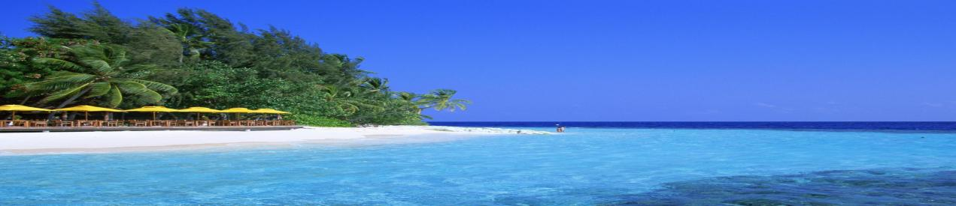
Hawaii, the island where many people dream of going, whether it is a honeymoon, a tourist destination for friends, or families. The literary master Mark Twain once said, "Hawaii is the most beautiful island in the ocean, and it is the loveliest island fleet anchored in the ocean. "It is true that it is difficult to find a tropics like Hawaii that is completely relaxing. environment.
Hawaii
The ancient town of Kailua
Kailua-Kona, also known as "Kaliua" (Kaliua), "Kona Town" (Kona Town), sometimes called "Town", it is only a 15-minute drive from Kona International Airport. A seaside town in the center of the coast of Navarre. The ancient town of Kailua was a quiet and leisurely fishing village in ancient times。

This small but beautiful beach has crystal clear blue waters, tall palm trees, rarely sheltered, and it can be called the best physical shelter on the island. The endless waves can push you through the waves just right, but they won't rush to impact your body.
Magic Beach Park
Hawaii Volcanoes National Park
The park includes two active volcanoes: Kīlauea Kilauea (one of the most active active volcanoes in the world) and Mauna Loa. The Kilauea overlook in the park is the best and safest viewing spot to watch Kilauea Volcano. There are volcanic rocky landforms along the way, with endless surprises that will make you breathless.
4 | 5 | 6 | 7 | 8
Punaluu Black Sand Beach | South Point and Green Sand Beach | Mauna Kea | Waikiki Beach | Diamond Head

