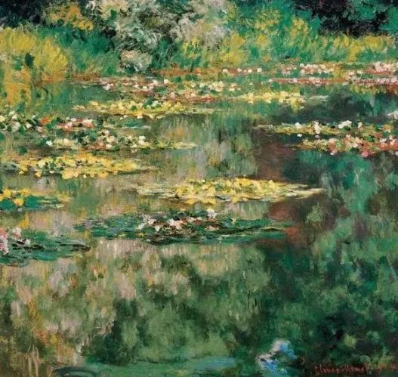
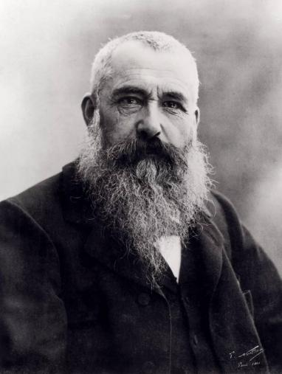
Oscar-Claude Monet ; 14 November 1840 – 5 December 1926) was a French painter and founder of impressionist painting who is seen as a key precursor to modernism, especially in his attempts to paint nature as he perceived it. During his long career, he was the most consistent and prolific practitioner of impressionism's philosophy of expressing one's perceptions before nature, especially as applied to plein air (outdoor) landscape painting. The term "Impressionism" is derived from the title of his painting Impression, soleil levant, exhibited in 1874 in the first Salon des Refusés ("exhibition of rejects") initiated by Monet and his associates as an alternative to the Salon.
Oscar-Claude Monet

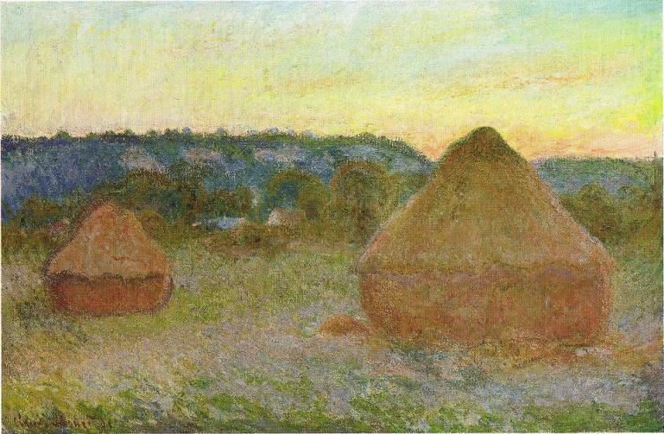
Monet was raised in Le Havre, Normandy, and became interested in the outdoors and drawing from an early age. Although his mother, Louise-Justine Aubrée Monet, supported his ambitions to be a painter, his father, Claude-Adolphe, disapproved and wanted him to pursue a career in business. He was very close to his mother, but she died in January 1857 when he was sixteen years old, and he was sent to live with his childless, widowed but wealthy aunt, Marie-Jeanne Lecadre. He went on to study at the Académie Suisse, and under the academic history painter Charles Gleyre, where he was a classmate of Auguste Renoir.

