- I was standing outside on a hot summer night in Florida and just a few miles from the ocean.
I was waiting for a miracle to happen. That summer, I was privileged to work as an intern at NASA's Kennedy Space Center, and the miracle I was waiting for was the launch of the Columbia Space Shuttle carrying the Chandra X-Ray Observatory, a telescope that would allow scientists to peer into the edge of black holes.
- The entire sky filled with light.
And it was as if it was daytime in the middle of the night. Soon, we could feel the rumble of the engines vibrating in our chests. And it wasn't a miracle; it was the combined effort of a team of thousands of people who worked together to make was seemed impossible a reality. And I wanted to join that team.
- So I decided to apply to a university where I could study aerospace engineering.
And the following year, I started at MIT in my engineering training and joined a student project building space robots. And everything was going as I planned, except I was confused about something important.
Now, my confusion arose in my summer breaks. I traveled to a school in Kenya, and there I volunteered with girls ages five to 17, giving them lessons in English and math and science. And they taught me songs in Swahili. And mostly,
- I just spent time getting to know the girls, enjoying their presence.
And I saw that these girls and the leaders in their community, they were overcoming important barriers to allow these girls to have the best possible chances in life. And I wanted to join that team.
I wanted to be part of a team that would help break down barriers and improve the lives of girls around the world. But I was worried that studying aerospace engineering wasn't the most useful. I was worried this team in Kenya couldn't use the technology I was learning about space.
- But thankfully, I still learned that I was wrong.
I came back and interned at NASA again, and this time, a mentor taught me that countries like Kenya had been using space technology for decades to improve the lives in their own countries. And then I knew that I could have a career in space and in development.
No. | Work Item | Tasks | Planned time | Completion time
1 | Promotion | Marketing | Oct.8,2021 | Oct.10,2021
2 | Price | Purchasing | Nov.8,2021 | Nov.9,2021
3 | Product | Updating | Nov.20,2021 | Nov.23,2021
4

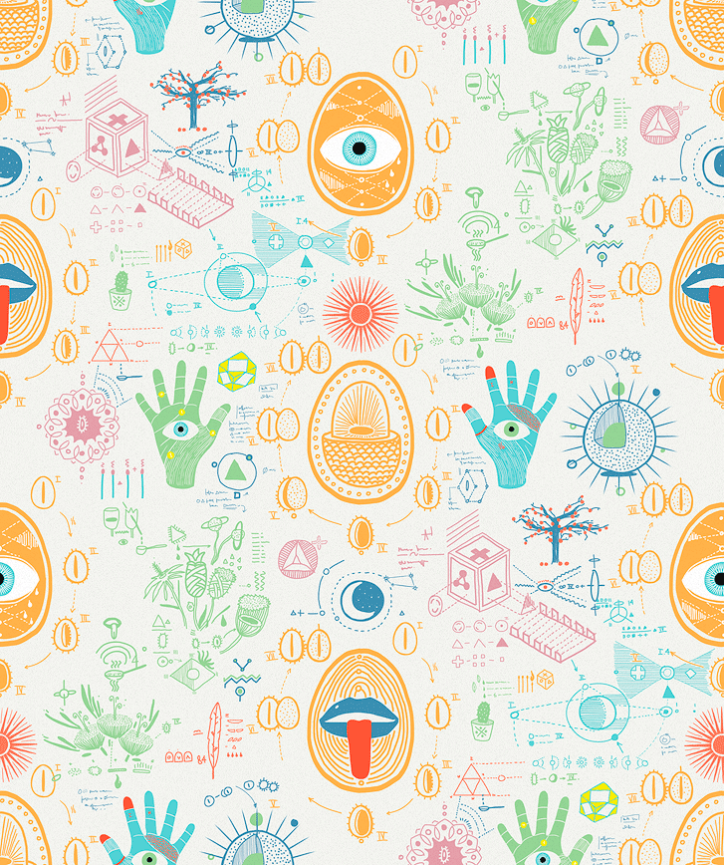
WPS academy

