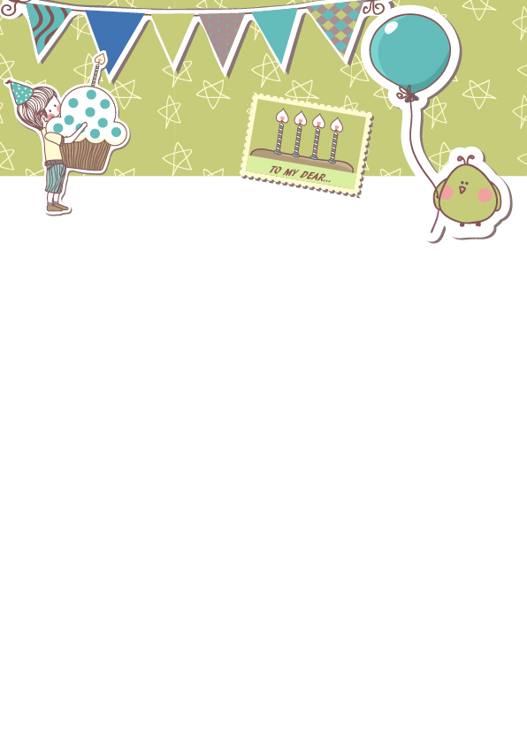

Happy Party Time

Friends arrived, took photos with birthday stars, and handed out party supplies
Impromptu show
Organize games to stimulate the atmosphere of the event
Sing a birthday song, light candles for birthdays and make wishes
Divide the cake, share happiness, share gifts
Line up for hygiene, hand out small gifts, and take group photos

