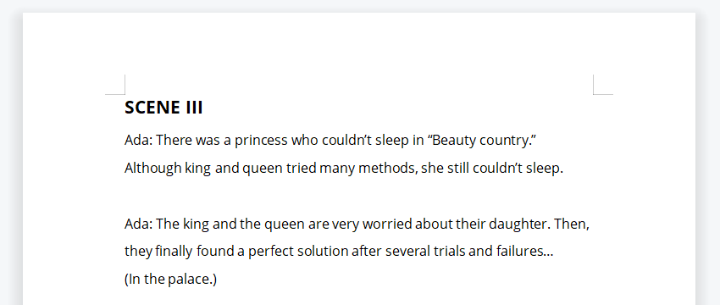

Queen: I am the queen!
King: Of course I am the king!
Queen: You never care about your daughter!!!
King: So…what happened to our baby?
Queen: My dear daughter can’t sleep!
King: So…what can we do?
(Queen brings many kinds of pills to her daughter.)
King: Oh~my dear, just take them all.
Princess: Take them all? Are you sure?
King: Yes!
Princess: (Take medicine) I still can’t sleep me still can’t sleep!
(Try another method.)
King: Hey my dear! Dad teaches you a good way to fall sleep: Counting Sheep.
Princess: 1 sheep 2 sheep 3 sheep …..
(Try a third method.)
Queen: I know a girl with a beautiful voice. Maybe she can make our daughter sleep.
King: Yes yes! (Open the door) Is she the one? (See Ada)
Queen: Oh~no!
King: Is she the one?
Queen: Of course! Please start singing!
Rita: I am a magic singer. (Clean the throat.) Can I start to sing?
Rita: Baby sleep. Baby sleep. Baby hurry to sleep. Everybody sing with me….
Princess: Shut up! Get out of here!!
King: I think these methods are not good ideas. We’ll think of better ideas.
Queen: Hum…I have an idea….maybe we can…..
King: You can say that again.
Queen: Let’s get ready.
(King and queen are preparing …)
Princess: Daddy! Mommy! It’s time to sleep! Don’t forget to take medicine.
(King and queen are disguised as ghosts in order to scare the princess to sleep.)
King: Oh, no! It didn’t work. Maybe we should get help from people.
Queen: OK! (Point to Ada) You just do it. Go out on the streets and find some help.

